**ACPPLD ALE 2020 hosted by SW2 region**

**Living and ageing with complex disability**

**Monday 9th – Wednesday 11th November 2020,**

**Mercure Grand Hotel, Bristol**

Registration will be opening soon for the 2020 ACPPLD Annual Learning Event. This year we have taken the opportunity to join forces with the British Society of Rehabilitation Medicine (BSRM) and Society of Research in Rehabilitation (SRR) to offer members an inspiring and thought provoking research and clinical programme. There will be presentations from national and international rehabilitation experts including plenty of LD specific content on the conference theme of living and ageing with complex disability.

**Invited speakers include**

|  |  |
| --- | --- |
| Professor Pauline Heslop | * **Professor Pauline Heslop, Professor of Intellectual Disabilities Studies, University of Bristol,** on improving healthcare and avoiding the premature deaths of people with LD. Professor Heslop was the lead author of the 2013 *‘Confidential inquiry into premature deaths in people with learning disabilities’* and is Programme Manager for the Learning Disabilities Mortality Review (LeDeR) until May 2020. |
| https://www.acpin.net/wp-content/uploads/2019/12/MCPL4750_2.png | **Dr Stephen Ashford, NIHR Clinical Lecturer and Consultant Physiotherapist at Northwick Park Hospital and Kings College London**, on spasticity screening, assessment, treatment and outcome measurement. Dr Ashford is an expert physiotherapist, he edited the national guidelines on spasticity management published in 2018 by the Royal College of Physicians.. He also developed the Arm Activity measure (ArmA) and Leg Activity measure (LegA); capturing patient/carer reported changes in passive and active function. |

**Monday 9th November** – The first day will have a clinically focussed programme led by BSRM and ACPPLD. There will be sessions on orthopaedic issues and interventions (speaker tbc) and spasticity with Stephen Ashford. There will be time to cover these areas in depth and ask questions and there will also be an evening social event.

**Tuesday 10th November** – The full joint multidisciplinary conference programme begins, incorporating free paper sessions (oral presentations of selected accepted abstracts), poster sessions and speakers from mainstream and LD on healthy ageing, osteoporosis, frailty and LeDeR (with Pauline Heslop). To share learning and focus on implementation the day will finish with a multidisciplinary workshop on strategies to enhance health and wellbeing for people who are vulnerable to frailty or frail. There will be a drinks reception and conference dinner.

**Wednesday 11th November -** The joint multidisciplinary conference continues with invited speakers and research papers and posters. A suggested session is on implementation science i.e. the science of getting more research into clinical practice so that it can really improve people’s lives.

Following the hugely successful student day preceding the SRR/BSRM conference in 2019 the conference organising committee decided to repeat it in 2020. This event is all about attracting the clinicians of the future into rehabilitation and therefore the conference will now be held in a university city, Bristol. Apologies for the change in conference dates and location that were needed to make this all possible. The multidisciplinary student day is planned for Sunday 8th November 2020 with speakers and a free lunch to attract students from all healthcare disciplines. ACPPLD SW2 will influence this programme to showcase the needs of people with learning disabilities and LD as an attractive specialism.

Registration and abstract submission will be handled centrally. There will the usual ‘pick and mix’ approach to booking days and residential options and of course a discount for ACPPLD members. We hope ACPPLD members will consider submitting abstracts. If anyone wants support to do this please see the December 2019 newsletter or get in touch with the SW2 committee members. Abstracts can be submitted in different categories such as research, audit, case study etc and there will be a new category this year for ‘evidence into clinical practice’. All abstracts will be peer reviewed and successful submissions will be invited to give a poster or oral presentation.

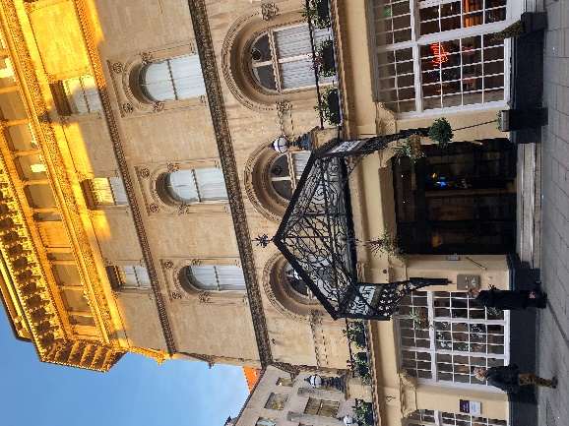Bristol is a vibrant and fascinating city and we hope you will enjoy your visit, for more information please visit the visit Bristol website (<https://visitbristol.co.uk/inspire/all-about-bristol/interesting-facts>). The conference will be held at the Mercure Grand Hotel in central Bristol less than 15 minutes walk from the main station and in the middle of shopping and visitor attractions. For anyone arriving on Sunday we plan a Banksy themed walk with a pub stop(s). The hotel is a Grade II listed building that has benefited from ongoing care and refurbishment. There is adjacent and nearby pay and display parking and GWR will be offering ticket discounts on their train lines. Bristol airport has great transport links into the city.

**The ACPPLD SW2 organising committee enthusiastically invite you to share in this unique collaborative opportunity and share some of their thoughts on this year’s ALE below.**

‘I think the prospect of a joint ALE with BSRM and SRR gives a valuable opportunity to raise the profile of Learning Disability Physiotherapy with the medical and other rehabilitation professions as well as encouraging LD physiotherapists to undertake more research.’ Nicola Harmer

‘Excited for this year’s ALE with a different approach of collaborating with BSRM and SRR. This gives us a chance to showcase the work we do in learning disabilities and also learn from other professionals.’ Vasanth Sampath

‘I’m very much looking forward to ALE 2020 with its new model and collaboration. It’s an exciting programme combining best practice in LD and the latest research’. Bethan Evans

We are looking forward to seeing you in Bristol

Best wishes

The ACPPLD SW2 2020 organising committee, Beth, Nicola, Vas, Carrie, Heather, Sue, Carrie, Ram, Marion and Ingrid.