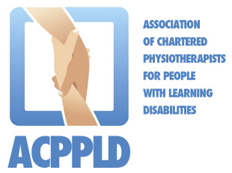

Standards of Practice for Physiotherapist working with Adults with a Learning Disability
Call For
PRACTICE EXAMPLES

There are examples of great practice happening across the UK which improves the health lives of adults with a learning disability.

We need to develop a body of practice examples which outlines the impact the profession has on:
Clinical outcomes
The experiences of adults with a learning disability and their network of cares
Cost savings for health and social care.

Therefore, we need examples of good practice, including:
- Local service models and pathways
- Local initiatives
- Case studies or series
- Local research and audits
- Quality improvement projects

These will support physiotherapists and services to develop their own practice, but support us to evidence how specialist physiotherapy deliver successful outcomes.

Best practice example will be accessible for all on the Standards of Practice home page.

There is guidance on writing the examples on the Supporting Document and Toolkits section of the website https://acppld.csp.org.uk/content/toolkits-and-supporting-documents.

Send your examples to Sarah Bruce (sarah.bruce@gstt.nhs.uk) or David Standley (david.standley@gstt.nhs.uk) and please do not hesitate to contact us if you have any questions.

