**Using the ACPPLD Logo**

The ACPPLD logo is at the heart of the professional networks work to promote the physiotherapy needs of people with a learning disability and specialist learning disability physiotherapists.

We have developed guidelines to ensure that the brand and logos are used in a consistent and effective way.

**ACPPLD Members' Logo**

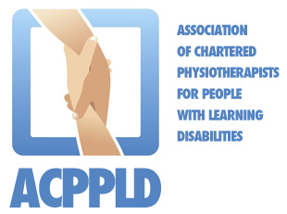 

The ACPPLD Members' Logo can be used by full ACPPLD members on website, stationery, directory listings, promotional leaflet, plaques, etc…to denote their membership of the association. However, does not indicate that it is endorsed by the ACPPLD. The logo **is not to be used for professional, personal or service publicity.**